OPPOSITION Nо B 3 221 196

Groupe Courrèges, 40, rue François 1er, 75008 Paris, France (opponent), represented by Cabinet @mark, 16, rue Milton, 75009 Paris, France (professional representative)

a g a i n s t

Alexia Cofiño Romero, 201 Rue St Honore, 75001 Paris, France and Armando Leal Salazar, 53 Bolsover Street, Flat D, W1W 5NG London, United Kingdom (applicants).

On 26/09/2025, the Opposition Division takes the following

DECISION:

1. | Opposition No B 3 221 196 is rejected in its entirety.

2. | The opponent bears the costs.

REASONS

On 30/07/2024, the opponent filed an opposition against all the goods of European Union trade mark application No 19 020 725 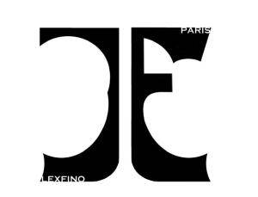 (figurative mark). The opposition is based on European Union trade mark registration No 18 932 008 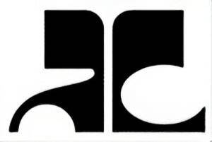 (figurative mark). The opponent invoked Articles 8(1)(b) and 8(5) EUTMR.

LIKELIHOOD OF CONFUSION — ARTICLE 8(1)(b) EUTMR

Pursuant to Article 8(1)(b) EUTMR, a likelihood of confusion exists if there is a risk that the public might believe that the goods or services in question, under the assumption that they bear the marks in question, come from the same undertaking or, as the case may be, from economically linked undertakings. Whether a likelihood of confusion exists depends on the appreciation in a global assessment of several factors, which are interdependent. These factors include the similarity of the signs, the similarity of the goods and services, the distinctiveness of the earlier mark, the distinctive and dominant elements of the conflicting signs, and the relevant public.

a) The goods

The goods on which the opposition is based are the following:

Class 14: Jewellery; Ornaments [jewellery, jewelry (Am.)]; Precious stones; Chronometric apparatus and instruments; Gold jewellery; Body-piercing rings; Jewellery boxes; Presentation boxes for jewellery; Jewellery made from silver; Earrings; Bracelets; Rings [jewellery]; Cuff links; Brooches [jewellery]; Necklaces [jewellery]; Pendants; Key rings [split rings with trinket or decorative fob]; Watches; Bracelets and watches combined; Watch cases [parts of watches]; Clocks; Alarm clocks; Tie pins; Tie-clips.

Class 25: Clothing; Children's wear; Sportswear; Clothing made from leather or imitation leather; Articles of clothing for theatrical use; Tops [clothing]; Shirts; Shirt fronts; Tee-shirts; Sweat shirts; Hooded sweatshirts; Sweaters; Waistcoats; Crossover tops; Cardigans; Sweaters; Twin sets; Teddies (undergarments); Skirts; Dresses; Trousers; Shorts; Coverups; Jumper suits; Collars [clothing]; Suits; Dinner suits; Tailleurs; Uniforms; Coats; Raincoats; Evening coats; Furs [clothing]; Blousons; Jackets [clothing]; Bushjackets; Cloaks; Frock coats; Gabardines; Overcoats; Trench coats; Parkas; Nightwear; Pyjamas; Nighties; Dressing gowns; Dressing gowns; Lingerie; Underwear; Bathing trunks; Bathing suits; Braces [suspenders] for clothing; Belts [clothing]; Neckties; Ascots; Bowties; Pocket squares; Sashes for wear; Kerchiefs [clothing]; Bandanas [neckerchiefs]; Stoles; Tights; Gloves [clothing]; Fingerless gloves; Headgear; Hosiery; Skull caps; Headbands [clothing]; Footwear [excluding orthopedic footwear]; Beach, skiing, sports shoes; Boots; Ankle boots; Sandals; Slippers; Socks.

The contested goods are the following:

Class 14: Jewellery; Pendants [jewellery]; Necklaces [jewellery]; Lockets [jewelry]; Fashion jewellery; Bracelets [jewelry].

Class 25: Clothing; Parts of clothing, footwear and headgear; Combinations [clothing]; Headgear; Footwear; Ready-made clothing; Clothes; Knitwear [clothing]; Menswear; Formalwear; Denims [clothing]; Denim jeans; Denim jackets; Denim pants; Jeans; Trousers of leather; Casual trousers; Trousers.

The relevant factors relating to the comparison of the goods or services include, inter alia, their nature, their intended purpose, their method of use and whether they are in competition with each other or are complementary (‘the Canon criteria’). It is also necessary to take into account, besides the Canon criteria, other factors, namely distribution channels, the relevant public and the usual origin of the goods or services (02/06/2021, T‑177/20, Hispano Suiza / Hispano Suiza, EU:T:2021:312, § 21-22).

Contested goods in Class 14

All the contested goods are identical to the opponent’s jewellery, either because they are identically contained in both lists (including synonyms) or because the opponent’s goods include the contested goods.

Contested goods in Class 25
Headgear is identically contained in both lists of goods (including synonyms).

The contested clothing; combinations [clothing]; ready-made clothing; clothes; knitwear [clothing]; menswear; formalwear; denims [clothing]; denim jeans; denim jackets; denim pants; jeans; trousers of leather; casual trousers; trousers are identical to the opponent’s clothing, either because they are identically contained in both lists (including synonyms) or because the opponent’s goods include the contested goods.

The contested footwear includes the opponent's footwear [excluding orthopedic footwear]. Therefore, they are identical.

The contested parts of clothing is similar to the opponent's clothing because clothing includes brassieres and parts of clothing include goods such as bra straps, which are usually removable and can be sold separately. Therefore, the goods at issue can target the same relevant public, share the same distribution channels and be produced by the same undertakings. Furthermore, they can also be complementary to each other.

The contested parts of footwear is similar to the opponent's footwear [excluding orthopedic footwear] because parts of footwear include goods such as inner soles which are removable and can be sold separately from footwear. Therefore, the goods at issue can target the same relevant public, share the same distribution channels and be complementary to each other.

The contested parts of headgear is similar to the opponent's headgear because headgear includes caps and parts of headgear include goods such as neck flaps, which can be sold separately as detachable parts of caps. Therefore, the goods at issue can target the same relevant public, share the same distribution channels and be produced by the same undertakings. Furthermore, they can also be complementary to each other.

b) Relevant public — degree of attention

The average consumer of the category of products concerned is deemed to be reasonably well informed and reasonably observant and circumspect. It should also be borne in mind that the average consumer’s degree of attention is likely to vary according to the category of goods or services in question (22/06/1999, C-342/97, Lloyd Schuhfabrik, EU:C:1999:323, § 26).

In the present case, the goods found to be identical or similar target the public at large.

The degree of attention is considered to be average.

c) The signs

Earlier trade mark | Contested sign

The relevant territory is the European Union.

The global appreciation of the visual, aural or conceptual similarity of the marks in question must be based on the overall impression given by the marks, bearing in mind, in particular, their distinctive and dominant components (11/11/1997, C‑251/95, Sabèl, EU:C:1997:528, § 23).

Both signs are figurative marks.

The contested sign is composed of two figurative devices, which could be perceived as the two letters ‘JE’ or ‘CE’ (with the first letter ‘C’ represented backwards) placed back-to-back or as abstract figurative elements.

The opponent refers to the earlier mark as a figurative sign consisting of ‘two figurative letters, back to back and inverted, with alternating thin lines of varying thickness’. It must be firstly noted that when applying for the earlier European Union trade mark, the opponent indicated ‘PY’ as the verbal elements in the sign. However, according to Article 3(2) EUTMIR, it is the representation of the trade mark that defines the subject matter of the registration. Therefore, the verbal elements as indicated by the opponent in its application of the earlier mark may not extend the scope of protection of the mark. In case of a discrepancy between the mark’s representation and its description, the representation of the mark prevails. Furthermore, it is irrelevant that the particulars of the earlier mark indicate a verbal element on the Office’s trade mark register or that the opponent refers to its mark by a verbal element in the application for trade mark registration, because the consumer will not be assisted by that information on encountering the signs as applied for or as registered.

The earlier mark could be perceived as a highly stylised representation of the letters ‘AC’, or as two abstract figurative elements.

Consequently, although both signs could be perceived in different ways, the Opposition Division will assess the signs from the perspective of the part of the public that will perceive the earlier mark as a stylised depiction of the letters ‘AC’ and the contested sign as the letter combination ‘CE’, which, due to the coincidence in one letter, is the most advantageous scenario for the opponent.

This letter combination in both signs has no obvious connection with any of the goods at issue, and is, therefore, distinctive.

The verbal element ‘LEXFINO’ of the contested sign is meaningless and distinctive. The verbal element ‘PARIS’ will be perceived as the geographical origin of the goods and, given that Paris is well known in relation to the goods concerned, it is non-distinctive.

The earlier mark has no element that could be considered clearly more dominant than other elements.

The stylised representation of the letters ‘CE’ in the contested sign is the dominant element as it is the most eye-catching. Due to their smaller size and position within the sign, the verbal elements ‘LEXFINO’ and ‘PARIS’ play a secondary role.

Visually, the signs coincide in that they both depict two highly stylised black letters, placed side by side, and they both include the letter ‘C’ albeit in different position. The signs also coincide in that they feature curved and pointed ends and are separated by a straight white line. However, they differ in their additional letters, ‘A’ of the earlier mark and ‘E’ of the contested sign, the secondary verbal elements ‘LEXFINO’ and ‘PARIS’ of the contested sign, and the graphical differences in the depiction of the letters in each sign. The lines of the letters in the earlier mark have varying thickness, very thick lines in the upper part and thinner lines in the lower part and have soft and straight endings. The lines of the contested sign are thin and of constant size and the ending of each line is curved inwards. While the rounded line in the ‘A’ of the earlier mark is a circle and the inner space of its letter ‘C’ is an oval shape, the curved lines in the contested sign are rather irregular, and are broken in their middle, including a pointed ledge in the case of the ‘C’ and a straight line in the case of the ‘E’. Moreover, the letter ‘C’ of the contested sign is represented facing the opposite way.

The length of the signs may influence the effect of the differences between them. The shorter a sign, the more easily the public is able to perceive all of its single elements. Therefore, in short words, small differences may frequently lead to a different overall impression (13/09/2023, T‑473/22, LAAVA (fig.) / Lav (fig.) et al., EU:T:2023:543, § 51; 26/04/2023, T‑153/22, XTG (fig.) / Gtx, EU:T:2023:217, § 39). In contrast, the public is less aware of differences between long signs.

Therefore, the signs are visually similar to a very low degree.

Aurally, irrespective of the different pronunciation rules in different parts of the relevant territory, the pronunciation of the signs coincides in the pronunciation of the letter ‘C’, present identically in both signs, albeit in different position. Being composed of two letters, the public under analysis will most likely pronounce both signs as independent letters (‘A’-‘C’ of the earlier mark versus ‘C’-‘E’ of the contested sign). The pronunciation differs in the sound of the differing letters, ‘A’ of the earlier mark and ‘E’ of the contested sign.

As regards the elements ‘LEXFINO’ and ‘PARIS’, given their secondary position within the sign, they are unlikely to be pronounced. Case-law confirms that consumers generally refer to the dominant elements while less prominent elements are not pronounced (03/07/2013, T‑206/12, LIBERTE american blend (fig.) / La LIBERTAD et al., EU:T:2013:342, § 43-44) and, in any case, consumers tend to shorten marks containing several words.

Therefore, the signs are aurally similar to a very low degree.

Conceptually, reference is made to the previous assertions concerning the semantic content conveyed by the marks. Whereas one of the marks is meaningless, the relevant public will perceive a concept of ‘PARIS’ in the other one. To that extent, the marks are conceptually not similar. However, this conceptual difference is of very limited relevance in the overall comparison of signs, as it stems from a non-distinctive meaning.

As the signs have been found similar in at least one aspect of the comparison, the examination of likelihood of confusion will proceed.

d) Distinctiveness of the earlier mark

The distinctiveness of the earlier mark is one of the factors to be taken into account in the global assessment of likelihood of confusion.

According to the opponent, the earlier trade mark enjoys enjoyed a high degree of distinctiveness due to its long and standing use in France in connection with all the goods for which it is registered. This claim must be properly considered given that the distinctiveness of the earlier trade mark must be taken into account in the assessment of likelihood of confusion. Indeed, the more distinctive the earlier mark, the greater will be the likelihood of confusion, and therefore marks with a highly distinctive character because of the recognition they possess on the market, enjoy broader protection than marks with a less distinctive character (29/09/1998, C‑39/97, Canon, EU:C:1998:442, § 18).

The enhanced distinctiveness of the earlier trade mark should exist at the time of filing of the contested EUTM application (or any priority date). In principle, it is sufficient that the opponent show that its mark had acquired enhanced distinctiveness on that date. Enhanced distinctiveness should also exist at the time when the opposition decision is taken. However, in principle, this will be assumed unless the applicant claims and proves any subsequent loss of enhanced distinctiveness.

In the present case, the contested trade mark was filed on 30/04/2024. Therefore, the opponent was required to prove that the trade mark on which the opposition is based enjoyed a high degree of recognition among the relevant public prior to that date.

The evidence must also show that the high degree of distinctiveness as a result of long standing and intensive use was acquired for the goods to which the opponent’s claim relates and that have been found identical or similar to the contested goods, namely:

Class 14: Jewellery.

Class 25: Clothing; Headgear; Footwear [excluding orthopedic footwear].

The opponent submitted the following evidence:

• Printouts of online press articles:

- Exhibit 1: Article ‘Les légendes de la mode’ (undated), which refers to ‘André Courrèges’ as ‘the great architect of clothing’. The sign 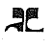is represented on the top left header of the article and in the picture dated 1970 of a handbag 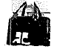, although does not make any reference to the sign in the text.
- Exhibit 2: Article in the book ‘Fashion. A history of 20th Century Fashion’ (undated). The sign appears represented in the picture of a dress  by ‘André Courrèges’.
- Exhibit 3: Article dedicated to ‘André Courrèges’ in the book ‘Les plus grands createurs de mode. De Coco Chanel à Jean Paul Gaultier’ (2012). It refers to André Courrèges as one of the greatest fashion designers which continues to inspire many contemporary designers. There is no reference to the earlier sign.
- Exhibit 4: Article in the book ‘Le Musee de la Mode’ (undated) which refers to André Courréges as a former engineer who learned from Balenciaga in the 1950s and became the leader of visionary fashion in Paris, as well as mentions the fresh daisy as its most distinctive symbol. It contains no reference to the earlier sign.
- Exhibit 5: Article published on the website vogue.fr in 9/03/2023, ‘The Courrèges style in 18 vintage photos’. It highlights the legendary cuts of the French house (Courrèges), but there is no reference to the earlier mark.
- Exhibit 6: Article published on the website matra-passion.com. The article was printed on 18/02/2025 but bears no visible publication date. It shows the car model ‘Matra Simca Bagheera Courréges series 1, which was presented on 30/09/1974. The following ‘Courrèges logo’ is displayed .
- Exhibit 7: Article ‘Courrèges: imagination as a legacy’ published on the website inpi.fr (undated). It refers to the fashion house founded by Andé and Coqueline Courrèges. There is no reference to the earlier sign.
- Exhibit 8: Article ‘Nicolas Di Felice, the designer who woke up Courrèges’ published on the website lemonde.fr (06/09/2023), which refers to Nicolas di Felice as the new artistic director of Courrèges in 2020, putting Courrèges back in the spotlight. It contains no reference to the earlier sign.
- Exhibit 9: Article ‘Courrège brand becomes trendy again on the catwalks and in the streets’ published on the website stylist.fr (2022). It mentions that Nicolas di Felice has succeeded in revisiting the brand ‘Courrèges’ sixty years after the creation of the brand. The sign is displayed in a picture as follows 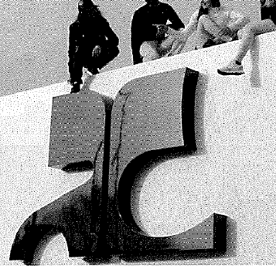, with no reference to the sign in the text of the article.
- Exhibit 10: Article ‘Courrèges, the rebirth of an era’ published on the website leclaireur.com (15/12/2022), referring to the luxury house Courrèges founded by André and Cocqueline Courrèges which revolutionised the world of women’s ready to wear in 1961, and which has a place in history. There is no reference to the earlier sign.
- Exhibit 11: Article ‘Courrèges, the rebirth of a French national treasure’ published on the website lefigaro.fr (04/03/2021) about the appointment in 2020 of Nicolas Di Felice as new creative director of the brand ‘Courrèges’. The earlier sign appears displayed in one of the clothing articles worn by a model .
- Exhibit 12: Article ‘Why Courrèges is the best fashion revival of recent years’ published on the website nssmag.com (29/09/2023). The article refers to the ‘Courrèges’ brand as a symbol of the 1960s. The earlier sign appears displayed as follows 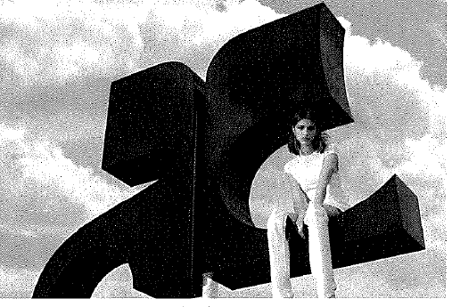 .
- Exhibit 13: Article ‘Courrèges, a story that continues to be written’ published on the website paperjam.lu (02/12/2014). It refers to the ‘Courrèges’ brand but there is no reference to the earlier sign.
- Exhibit 14: Article ‘First Fashion Week: First (successful) show for Nicolas Di Felice at Courrèges’ published on the website lemonde.fr (04/03/2021). Mentions the first ‘Courrèges’ collection by the Belgian designer, with no reference to the earlier sign.
- Exhibit 15: Article ‘The leather jacket gets a makeover’ published on the website lemonde.fr (09/01/2025), including the picture of a ‘Courrèges’ jacket. There is no reference to the earlier sign.
- Exhibit 16: Article ‘The history of Courrèges’ published on the website mariclaire.fr (undated). While it refers to the renewed interest in the ‘Courrège’ brand, the ‘Courrège’ fashion show as an event not to be missed, and as ‘Courrège’ as the symbol of an era, it makes no reference to the earlier sign.
- Exhibit 17: Article ‘Courrèges, the rebirth of a French national treasure’ published on the website lefigaro.fr (04/03/2021), where the only reference to the earlier sign is in one of the pictures of the fashion show as follows: 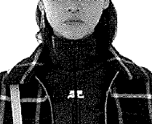.
- Exhibit 18: Article ‘The timeless Courrèges stamp’ published on the website lepoint.fr (01/02/2022). It mentions that the designer Nicolas Di Felice brought the historic symbol of the Parisian house up to date, and shows pictures which mention that ‘the fashion house is reconnecting with its original AC logo’ displayed in vinyl jackets as follow: 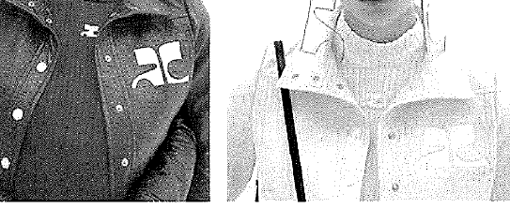. The article mentions that its first floral logo ‘was transformed into two letters, A and C, with their geometric typography of perfect circles and straight lines, placed back to back like two heads searching for the same entity’.
- Exhibit 19: Article ‘Courrèges adopts a new typography and changes its logo’ published on the website graphiline.com (22/04/2016), which displays the following old logo and typography and the new typography  and the new logo .
- Exhibit 20: Article in French (undated) published in an unknown publication, which includes the sign 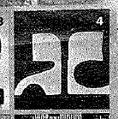 referring to it as the initials of ‘André Courrèges’.
- Exhibit 22: Article ‘Courrèges Fashion Show: Tina Kunakey Approves the Vinyl Jacket’ (undated) published on the website elle.fr. It refers to the success of the vinyl jacket designed by André Courrèges in 1971 and reissued by the artistic director Nicolas Di Felice. There is no reference to the earlier sign.
- Exhibit 23: Article ‘Celebrity Sparkle at the Courrèges Fall/Winter 2024 Fashion Show’ published on 08/03/2024 on the website luxsure.fr. It refers to the ‘house of Courrèges’ and the ‘Courrèges style’, mentioning that ‘Courrèges transcends generations and ephemeral trends’. However, there is no reference to the earlier mark.
- Exhibit 24: Article ‘The Holy bag from Courrèges, the new it-bag preferred by stars’ published on 29/07/2024 on the website stylist.fr. The article is dedicated to a bag which includes ‘a discreet embossed logo’ and ‘another silver one adds the Courrèges signature to this already popular bag (…) and the earlier mark is only visible in the bag shown in the pictures 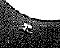.
- Exhibit 25: Article ‘Angèle, ultra-sexy in a vinyl jumpsuit with holes at the Courrèges fashion show’ published on 28/02/2024 on the website grazia.fr. It praises the look of a Belgian singer in the Courrèges fashion show. There is no reference to the earlier mark.
- Exhibit 26: Article ‘This French bag has all the fashion stars hooked’ published on 11/07/2024 on the website elle.fr. It relates to the success of the ‘Holy Bag’, which is ‘a bag from the well-known brand Courrèges’. The earlier mark is visible in a picture of the bag 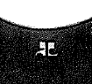.
- Exhibit 27: Article ‘Courrèges fashion show: Laetitia Casta looks sumptuous, shoulder-length, in an asymmetrical, low-cut, bodycon dress’ published on 24/09/2024 on the website purepeople.com. It mentions the attendance of the actress and model Laetitia Casta in the Courrèges fashion show at the Paris Fashion Week. The earlier mark is visible in the clothing worn by one of the attendees shown in the pictures 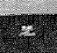.
- Exhibit 28: Article published on 03/04/2024 on the website vogue.fr about the collaboration between Courrèges and Mytheresa, showing pictures of the clothing items resulting from the collaboration, where the earlier mark is visible as follows .
- Exhibit 29: Article ‘Courrèges, the best jacked?’ (undated) published on the website styliste.fr, about the Courrèges fashion show and how the new designer has reworked ‘the famous in-house vinyl’ jacket designed by André Courrèges in the 60s.
- Exhibit 33: Printout of the review of the ‘Courrèges’ spring-summer 2025 fashion show, held in September 2024, published on the website styliste.fr. The earlier mark is only visible in the picture of a bag 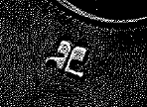.
- Exhibit 34: Article ‘This star jacket by Courrèges has us all hooked’ published on 21/03/2023 on the website hapersbazaar.fr, about the ‘Courrège jacket’, a ‘keypiece from the 1970s’. A picture shows the earlier mark depicted in a ‘Courrèges jacket’ 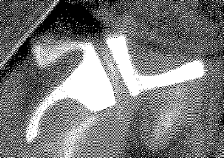 worn by Sharon Stone in the film ‘Casino’ in 1995.
- Exhibit 35: Article ‘Courrèges x Printemps, the exclusive back-to-school collaboration’ published on 28/08/2024 on the website printemps.fr. The earlier mark is featured in some clothing and headwear items shown in the pictures  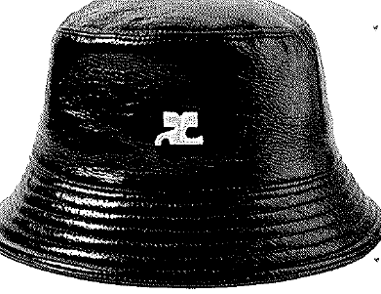 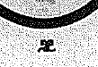.
- Exhibit 36: Interview made to ‘Nicolas Di Felice’, the creative director at ‘Courrèges’ published in the section ‘Stores news’ on the website printemps.fr, and related to Courrèges being the official guest of Printemps stores for the fall season 2024. It shows the earlier sign depicted in a bag 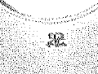 and a jacket 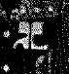

• Printed matter:

- Exhibit 21: Pictures of invitations to the fashion shows of ‘André Courrèges’ in 1969, 1971 and 1972, showing the sign  on the right.
- Exhibit 37: collection of printed press publications:
o Cover of the French magazine ‘Jardin des modes’ (September 1971) showing a model wearing a jacket with the earlier mark 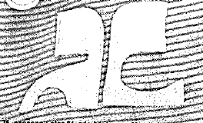.
o Undated ‘Vogue promotion’ of the new perfume of André Courrèges showing the earlier sign .
o Undated cover of the magazine ‘Marie Claire collections’ showing a model wearing a shirt with the sign .
o Undated article about André Courreges where the earlier sign can be inferred in the background 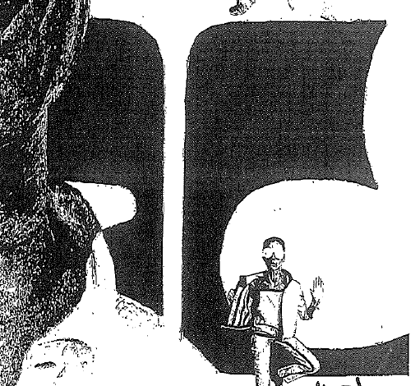.
o A ‘Courrèges’ jacket bearing the sign , displayed in a French magazine dated 2011.
o Undated article about ‘A new golf look’ which makes reference to ‘Courrèges’ offering women fashion for 50 years’ and mentioning that Evian Masters Japan’s Miki Saiki starred ‘not only with her golf but Courrèges new look skirts monogrammed and polos with their name in hot colors’. The article displays pictures of a bag and a jacket bearing the sign 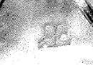.
o Article dated 29/09/2011 on ‘Le Point’ about the return of Courrèges, displaying pictures of clothing with the sign .
o Undated interview to André Courrèges, displaying the sign as follows 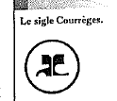.
o Undated article in a French magazine about Courrèges, displaying the sign  , perfumes with the sign , a bag with the sign .
o Undated article including a reference to the reedition of the vinyl jacket originally designed by André Courrèges.
o Compilation of pictures of ‘Courrèges’ articles published in magazines and websites during 2024 and 2025, where the sign is visible in bags, jackets, tops and skirts as follow 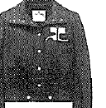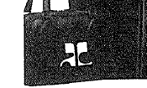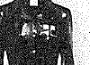.

• Social media accounts:

- Exhibit 30: printout of the ‘Courreges’ Instagram profile, with 607k followers and 704 publications, and the earlier mark is depicted in the profile picture . It includes publications showing clothing items bearing a small representation of the earlier mark .
- Exhibit 31: printout of the Facebook profile, with 5,300 followers. It depicts the earlier mark as follows 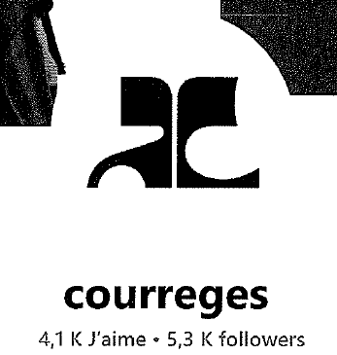. Includes publications showing clothing items bearing a small representation of the earlier mark .
- Exhibit 32: the ‘Courrèges’ YouTube account has 3,300 subscriptions and 15 videos, including ‘Courrèges’ Fashion shows. The earlier mark is only depicted as cover of ‘Courrèges Spring Summer 24 show’.

Having examined the material listed above, the Opposition Division concludes that the evidence submitted by the opponent does not demonstrate that the earlier trade mark acquired a high degree of distinctiveness through its use.

In making an assessment regarding enhanced distinctiveness, account should be taken, in particular, of the inherent characteristics of the mark, including whether or not it contains an element descriptive of the goods or services for which it has been registered; the market share held by the mark; how intensive, geographically widespread and long standing the use of the mark has been; the amount invested by the undertaking in promoting the mark; the proportion of the relevant section of the public that, because of the mark, identifies the goods or services as originating from a particular undertaking; and statements from chambers of commerce and industry or other trade and professional associations (22/06/1999, C 342/97, Lloyd Schuhfabrik, EU:C:1999:323, § 22).

Despite showing some use of the trade mark for clothing articles (jackets, tops, skirts), bags and perfumes, the evidence does not provide any information on the extent of such use. In particular, the evidence does not provide any indication of the degree of recognition of the trade mark by the relevant public. Furthermore, the evidence does not provide sufficient information about the sales volumes, the market share of the trade mark or to the extent to which the trade mark has been promoted. As a result, the Opposition Division cannot rely on any convincing indications that would serve the conclusion that the earlier mark is known on the respective market.

The extracts and screenshots from Instagram, Facebook and Youtube display the earlier mark, and indicate the number of followers, likes and viewers achieved. However, they do not provide any information regarding the territories from which these followers and viewers originate. Therefore, due to the global nature of social media accounts, these extracts and screenshots, by themselves, cannot be conclusive of any degree of knowledge of the earlier mark in the relevant territory.

The abovementioned evidence mainly refers to the word mark ‘Courrèges’, to the figurative mark or the earlier mark used as part of a composite mark which includes the verbal element ‘Courrèges’. There is very limited evidence of the earlier mark as registered used independently, which makes it difficult to establish that consumers are accustomed to focusing, in particular, in the earlier figurative mark () only, and not as part of a composite sign. The evidence only rarely appears on any of the evidence without the reference of the name ‘Courrèges’ or ‘André Courrèges’ next to it.

This is an important factor to be considered when assessing the enhanced distinctiveness or reputation of a mark that is usually incorporated in a more complex sign containing a further verbal element. Indeed, to establish the reputation of a trade mark on the basis of evidence relating to the use and well-known nature of a different trade mark, the former must be included in the latter and play therein ‘a predominant or even significant role’ (21/05/2005, T-55/13, F1H20 / F1 et al., EU:T:2015:309 § 47). When the earlier mark has been used as part of another mark, it is incumbent on the opponent to prove that the earlier mark has independently acquired a reputation (12/02/2015, T-505/12, B, EU:T:2015:95, § 121). In the present case, the opponent did not provide any evidence, e.g. a survey, opinion poll, press articles, where the earlier mark has been recognised on its own as a mark related to the opponent’s undertaking or has been considered a badge to be associated with those particular goods and having a particular commercial origin (namely, that of the opponent).

Use of a mark does not always amount to enhanced distinctiveness through its use or reputation. It is clear that the ‘AC’ () figurative mark has been used (e.g. in publications, sometimes directly on the products as logo or theme, and as the sign designating the opponent’s logo). However, the nature of that use has not been sufficient for that mark to come out from under the shadow of the ‘Courrèges’ or ‘André Courrèges’ name. The enhanced distinctiveness due to its extensive use or reputation of a trade mark must not be determined abstractly but must be linked to the relevant consumers’ perception. The opponent failed to prove that the public would associate the ‘AC’ sign () with the opponent’s fashion or jewellery goods.

Just as the finding of genuine use of a mark cannot be based on probabilities or suppositions but must be demonstrated by solid and objective evidence (18/01/2011, T-382/08, Vogue, EU:T:2011:9, § 22; 12/12/2002, T-39/01, Hiwatt, EU:T:2002:316, § 47), by analogy, the same criteria must apply to evidence of purported enhanced distinctiveness or reputation, for which the threshold is higher. The opponent was under the obligation to demonstrate the relevant public’s awareness of the trade mark, the intensity of use, or the size of the investment made by the undertaking in promoting the invoked earlier mark. All these factors must be taken into account in order to determine whether the earlier mark enjoys an enhanced degree of distinctiveness or reputation from the standpoint of the consumers targeted by the opponent.

As a result, the evidence does not show that the trade mark is known by a significant part of the French public, as claimed by the opponent. Under these circumstances, the Opposition Division concludes that the opponent failed to prove that its trade mark enjoys any enhanced distinctiveness, let alone, a reputation in the territory of the EU.

Consequently, the assessment of the distinctiveness of the earlier mark will rest on its distinctiveness per se. In the present case, the earlier trade mark as a whole has no meaning for any of the goods in question from the perspective of the public in the relevant territory. Therefore, the distinctiveness of the earlier mark must be seen as normal.

e) Global assessment, other arguments and conclusion

The goods are identical or similar and they target the public at large, whose degree of attention is average. As concluded in section d) of this decision, the earlier mark has a normal degree of distinctiveness. The signs are visually and aurally similar to a very low degree and conceptually not similar.

The signs display certain visual resemblances on account of the depiction of two highly stylised black letters, separated by a straight white line. However, in the opinion of the Opposition Division, these visual resemblances are outweighed by the differences between the signs are clearly perceivable.

Firstly, although the signs feature two letters, the shapes and lines making up these letters are different in each sign. In the earlier mark, the lines of the letters have different thickness and feature soft perfectly rounded shapes. In contrast, the contested sign’s lines have the same constant thickness and are rather thin. Moreover, the endings of the lines are also different, straight in the earlier mark and curved inwards in the contested sign. Secondly, the signs coincide in the presence of the letter ‘C’, although in different position and represented differently (facing left in the contested sign). The signs differ in the additional letters, ‘A’ (earlier mark) and ‘E’ (contested sign).

The overall composition of the contested sign creates an impression that is sufficiently removed from that of the earlier marks. Contrary to the opponent’s arguments, the contested sign will not be perceived as a mere variation, as its whole get-up conveys a different overall impression.

As noted above, the length of the signs plays a role in how differences are perceived. The shorter the signs, the more easily the public is able to notice and recall all individual elements. Therefore, in short signs, even minor differences can result in a different overall impression.

Therefore, the differences between the signs at issue are clearly perceptible and sufficient to outweigh the limited impact of the shared element (the letter ‘C’). The similarity based solely on this element is not capable of giving rise to a likelihood of confusion on the part of the reasonably well-informed, observant and circumspect public, even in relation to identical or similar goods. The mere presence of the letter ‘C’ in the signs is not sufficient to overcome the prominent differences in their structure, composition and overall impression.

Particular importance should be attached to the very low degree of visual similarity. Generally in clothes shops customers can themselves either choose the clothes they wish to buy or be assisted by the sales staff. Whilst oral communication in respect of the product and the trade mark is not excluded, the choice of the item of clothing is generally made visually. Therefore, the visual perception of the marks in question will generally take place prior to purchase. Accordingly the visual aspect plays a greater role in the global assessment of the likelihood of confusion (06/10/2004, T‑117/03, NLSPORT (fig.) / NL (fig.), EU:T:2004:293, § 50; 06/10/2004, T‑118/03, NLJEANS / NL, EU:T:2004:293, § 50; 06/10/2004, T‑119/03, NL (fig) / NLACTIVE, EU:T:2004:293, § 50; 06/10/2004, T‑171/03, NL Collection (fig.) / NL (fig.), EU:T:2004:293, § 50). Therefore, the considerable visual differences between the signs caused by the differing verbal elements and graphical aspects are particularly relevant when assessing the likelihood of confusion between them.

Considering all the above, there is no likelihood of confusion on the part of the public that will perceive the signs as the letters ‘AC’ (earlier mark) and ‘CE’ (contested sign). Therefore, the opposition must be rejected.

This absence of a likelihood of confusion equally applies to the part of the public that will perceive the signs as composed of different letters or figurative devices. For the part of the public that perceive both signs as composed of abstract figurative devices or differing letters, the signs would have even less commonalities. This is because, the visual similarity will be limited to the composition of two black abstract figurative devices divided by a straight white line with no other material coincidences. Therefore, for this part of the public, the signs are visually similar to an extremely low degree, at best. Moreover, when either one of the signs is purely figurative a phonetic comparison is not possible, and in any of the cases because of the presence of ‘LEXFINO’ and ‘PARIS’ in the contested sign, the signs are conceptually not similar.

Therefore, as a result of the non-coincidence in any letter or verbal element, that part of the public will perceive the signs as being even less similar.

REPUTATION — ARTICLE 8(5) EUTMR

In relation to Article 8(5) EUTMR, the opponent invoked earlier EUTM registration No 18 932 008.

According to Article 8(5) EUTMR, upon opposition by the proprietor of a registered earlier trade mark within the meaning of Article 8(2) EUTMR, the contested trade mark will not be registered where it is identical with, or similar to, an earlier trade mark, irrespective of whether the goods or services for which it is applied are identical with, similar to or not similar to those for which the earlier trade mark is registered, where, in the case of an earlier European Union trade mark, the trade mark has a reputation in the Union or, in the case of an earlier national trade mark, the trade mark has a reputation in the Member State concerned and where the use without due cause of the contested trade mark would take unfair advantage of, or be detrimental to, the distinctive character or the repute of the earlier trade mark.

Therefore, the grounds for refusal of Article 8(5) EUTMR are only applicable when the following conditions are met.

• The signs must be either identical or similar.

• The opponent’s trade mark must have a reputation. The reputation must also be prior to the filing of the contested trade mark; it must exist in the territory concerned and for the goods and/or services on which the opposition is based.

• Risk of injury: use of the contested trade mark would take unfair advantage of, or be detrimental to, the distinctive character or repute of the earlier trade mark.

The abovementioned requirements are cumulative and, therefore, the absence of any one of them will lead to the rejection of the opposition under Article 8(5) EUTMR (16/12/2010, T-357/08, BOTOCYL / BOTOX, EU:T:2010:529, § 41; 16/12/2010, T-345/08, BOTOLIST / BOTOX, EU:T:2010:529, § 41). However, the fulfilment of all the abovementioned conditions may not be sufficient. The opposition may still fail if the applicant establishes due cause for the use of the contested trade mark.

In the present case, the applicants did not claim to have due cause for using the contested mark. Therefore, in the absence of any indications to the contrary, it must be assumed that no due cause exists.

a) Reputation of the earlier trade mark

The evidence submitted by the opponent to prove the reputation and highly distinctive character of the earlier trade mark has already been examined above under the grounds of Article 8(1)(b) EUTMR. Reference is made to those findings, which are equally valid for Article 8(5) EUTMR.

The need for the earlier mark to be known by a significant part of the public also serves to mark the difference between the notions of reputation as a necessary condition for the application of Article 8(5) EUTMR and enhanced distinctiveness through use as a factor for evaluating likelihood of confusion for the purposes of Article 8(1)(b) EUTMR.

Even though both terms are concerned with the recognition of the mark among the relevant public, in the case of reputation a threshold exists below which extended protection cannot be granted, whereas in the case of enhanced distinctiveness there is no threshold. It follows that in the latter case any indication of enhanced recognition of the mark should be taken into account and evaluated according to its significance, regardless of whether it reaches the limit required by Article 8(5) EUTMR.

As explained previously the opponent has not proved enhanced distinctiveness of the earlier mark and, therefore, the threshold required for the earlier mark’s reputation to be established cannot be considered to be reached either.

As seen above, it is a requirement for the opposition to be successful under Article 8(5) EUTMR that the earlier trade mark has a reputation. Since it has not been established that the earlier trade mark has a reputation, one of the necessary conditions contained in Article 8(5) EUTMR is not fulfilled, and the opposition must be rejected.

COSTS

According to Article 109(1) EUTMR, the losing party in opposition proceedings must bear the fees and costs incurred by the other party.

Since the opponent is the losing party, it must bear the costs incurred by the applicants in the course of these proceedings.

According to Article 109(7) EUTMR and Article 18(1)(c)(i) EUTMIR, the costs to be paid to the applicants are the costs of representation, which are to be fixed on the basis of the maximum rate set therein. In the present case, the applicants did not appoint a professional representative within the meaning of Article 120 EUTMR and therefore did not incur representation costs.



The Opposition Division

Aldo BLASI | Irene MARUGÁN MARÍN | Agnieszka PRZYGODA

According to Article 67 EUTMR, any party adversely affected by this decision has a right to appeal against this decision. According to Article 68 EUTMR, notice of appeal must be filed in writing at the Office within two months of the date of notification of this decision. It must be filed in the language of the proceedings in which the decision subject to appeal was taken. Furthermore, a written statement of the grounds for appeal must be filed within four months of the same date. The notice of appeal will be deemed to have been filed only when the appeal fee of EUR 720 has been paid.

